Open-Source Anticipated Response Inhibition (OSARI) Assessment

The OSARI (He et al., 2022) is a neurocognitive assessment designed to measure executive control that can be completed on a cell phone, computer, or tablet. During this task, participants will hold a button to fill a bar to the point of a threshold (indicated by arrows). An example of this type of trial, called a GO trial, is included below.

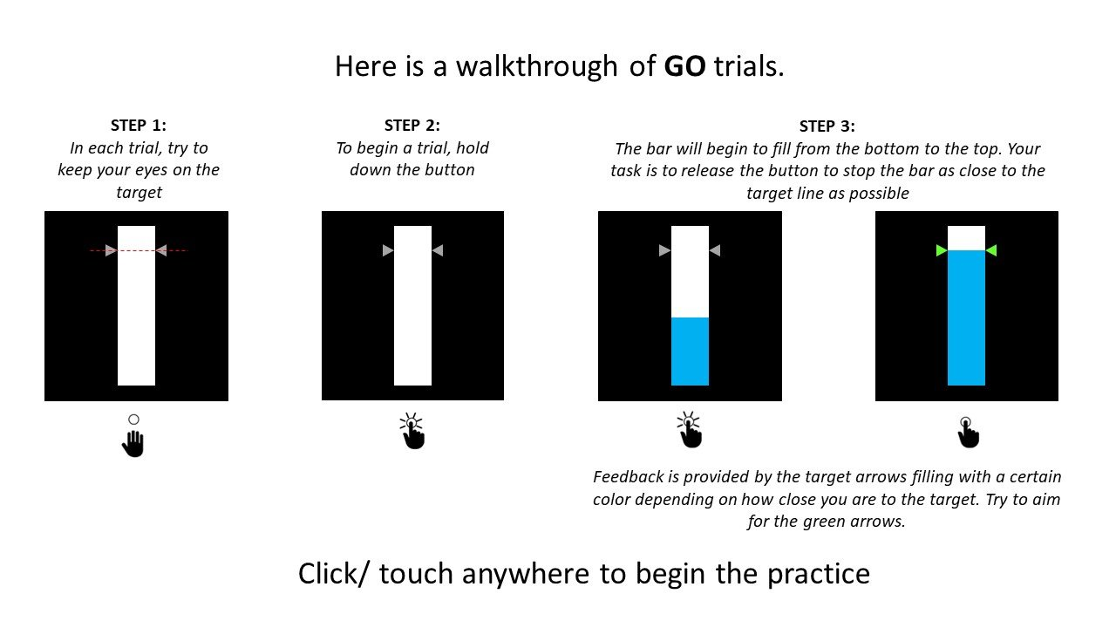

In some trials, the bar will randomly stop filling, and the participant must continue to hold the button until the indicator arrows turn green. This type of trial, called a STOP trial, is pictured below.

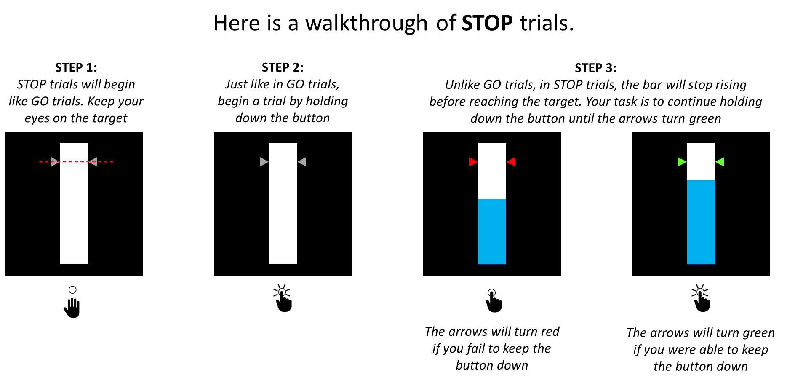

After reading the instructions for GO trials, participants complete 5 practice trials, followed by 50 GO trials. Participants are then introduced to STOP trials, and complete a practice with 5 GO trials and 5 STOP trials. After a small break, the participants begin the 3 experimental blocks. Each experimental block consists of 60 GO trials and 20 stop trials, in random order. The accuracy and response times are collected for all trials.

For both the practice and experimental trials, participants received feedback. In GO trials, if the participant stops the filling bar within 20 milliseconds of the target line, the indicator arrows turn green, and they received the feedback “Correct GO trial!” If the participant stops the bar between 20 and 40 milliseconds of the target line, the indicator arrows turn yellow, and they receive the feedback “Very close!” If the participant stops the bar between 40 and 60 milliseconds of the target line, the indicator arrows turn orange, and they receive the feedback “Try to stop the bar closer to the target.” If the participant does not stop the bar, the indicator arrows turn red and they receive the feedback “Oops! That was a GO trial and you did not make a response.” In STOP trials, participants must shift their decision criteria to the color of the arrows, instead of the height of the bar. If the participants continue to hold the filling bar until the arrows turn green, they receive the feedback “Correct! That was a STOP trial and you held your response!” If the participant releases the bar early, the indicator arrows turn red and they receive the feedback “That was a STOP trial. Try to hold until the arrows turn green.”

Throughout the experiment, the response time and accuracy are required for all trials. For STOP trials, the stop-signal delay (the time at which the bar stops filling) is also recorded. A measure for response inhibition can be calculated by comparing the mean response time in the practice GO trials to the mean of the first practice with mix trials. Additionally, the entire response time distributions can be fit with response time models, such as the shifted-Wald model, to assess the underlying cognitive mechanisms.

Note: Some components of this assessment have been updated for ease of use and visibility since the version created by He et al. (2022), but the experimental design remains the same.

He, J. L., Hirst, R. J., Puri, R., Coxon, J., Byblow, W., Hinder, M., ... & Puts, N. A. (2022). OSARI, an open-source anticipated response inhibition task. *Behavior Research Methods*, *54*, 1530-1540. https://doi.org/10.3758/s13428-021-01680-9